Citing with APA Basics

1. Citating with APA Basics

1.1 Temple Libraries Presents Citating with APA Basics
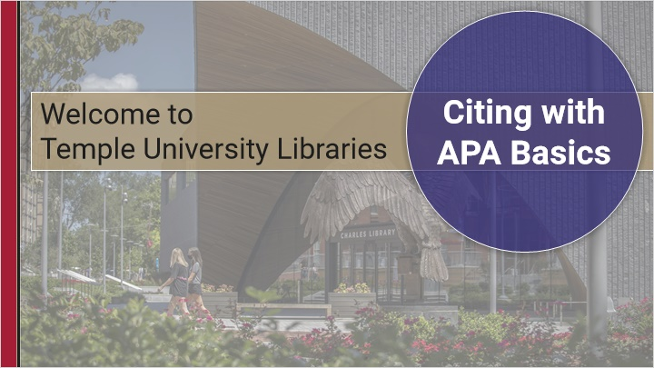
Notes:

1.2 Citing in APA style
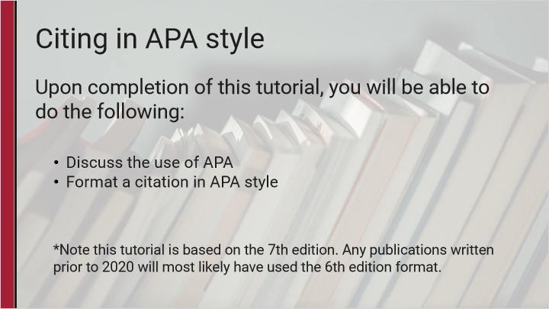
Notes:

1.3 Reference List vs In-Text
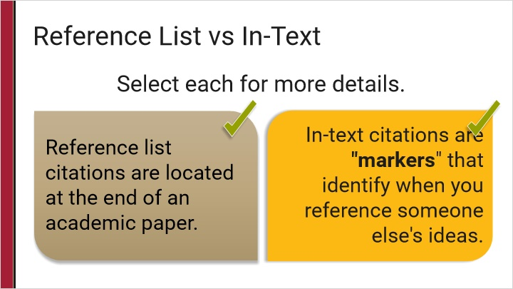
Notes:

Can't continue (Slide Layer)
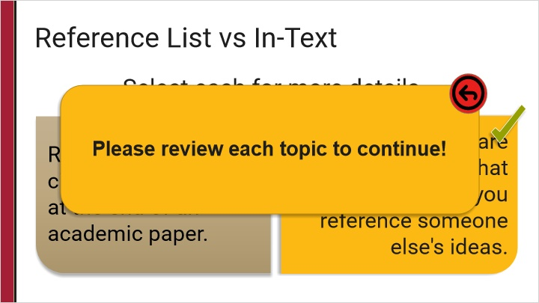

1.4 The Paper: Reference List
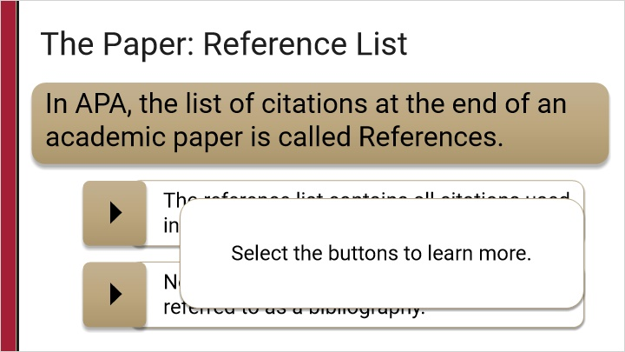
Notes:

1.5 Reference List: Journal Articles
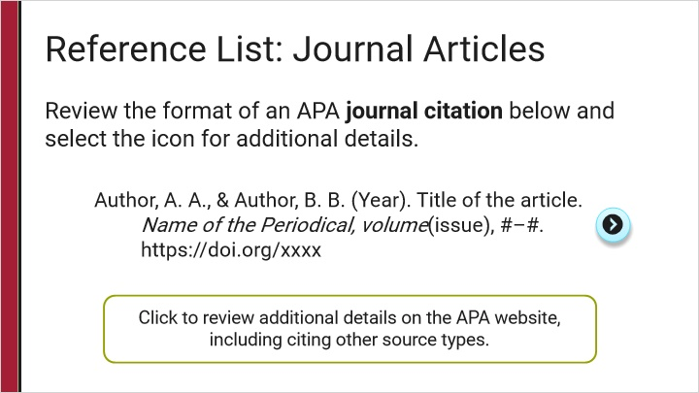
Notes:

Author is Group/Org (Slide Layer)
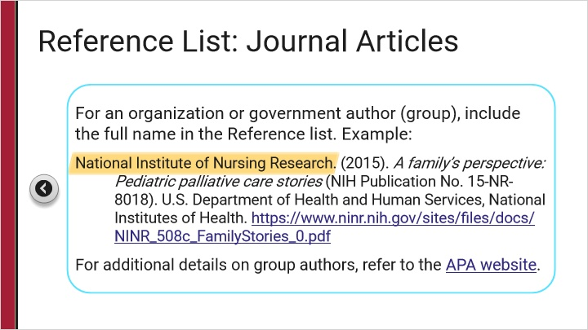

1.6 Reference List: Books
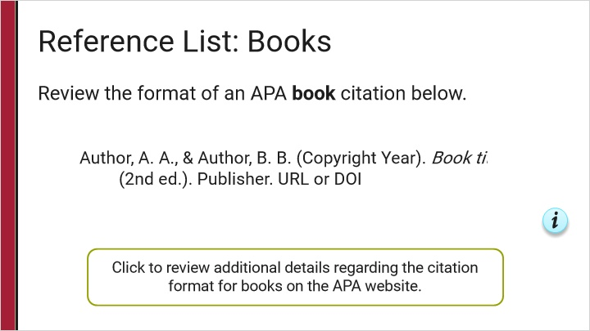
Notes:

DOI details (Slide Layer)
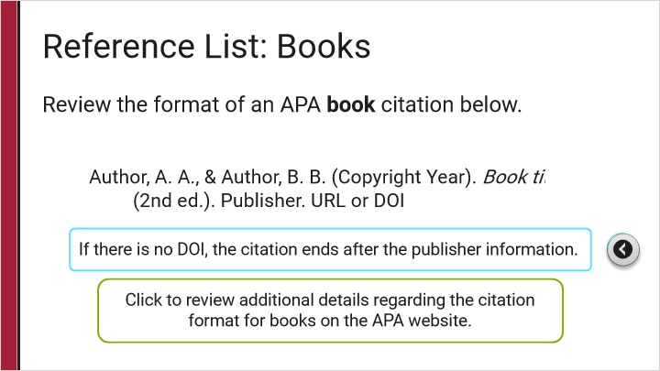

1.7 Reference List: Websites
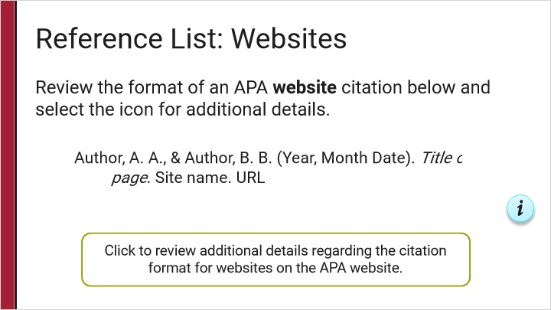
Notes:

Details (Slide Layer)
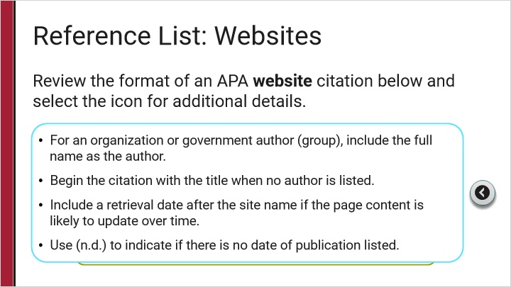

1.8 Draw from Click the citation part
Draw 1 questions randomly from Click the citation part

1.9 The Paper: In-text citing
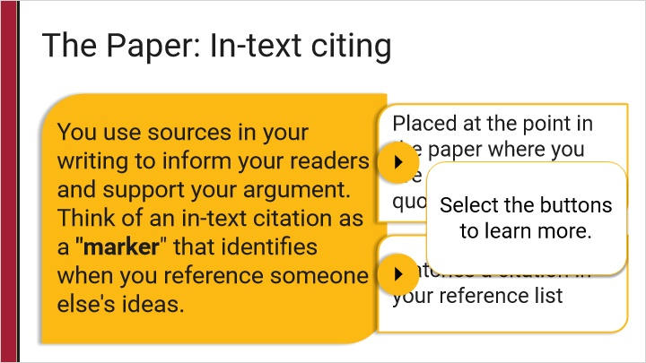

1.10 In-text format
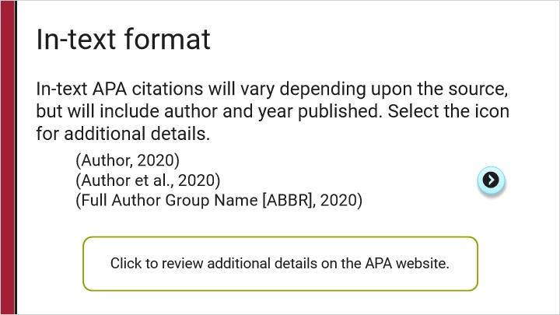
Notes:

Author is Group/Org Abbreviation (Slide Layer)
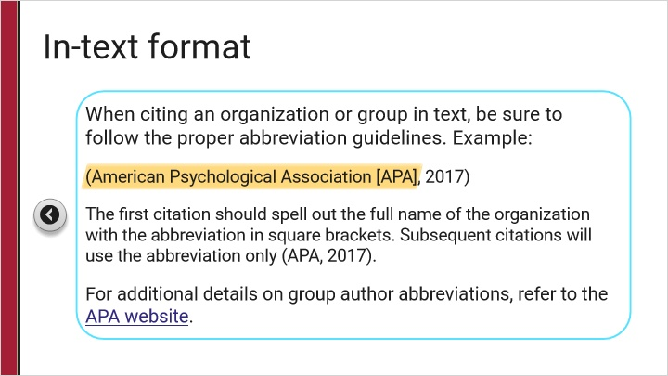

1.11 Try it Yourself!
(Multiple Choice, 10 points, 1 attempt permitted)
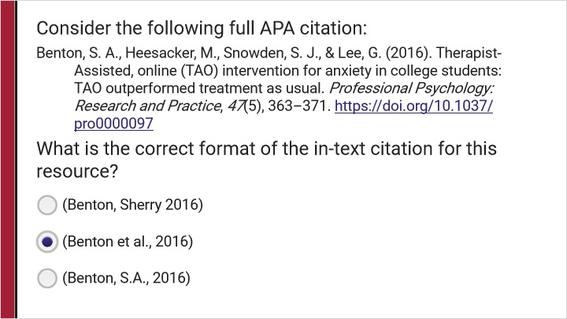
Correct | Choice
 | (Benton, Sherry 2016)
X | (Benton et al., 2016)
 | (Benton, S.A., 2016)
Feedback when correct:
That's right! (Benton et al., 2016) is the correct format.
Feedback when incorrect:
The correct format is (Benton et al., 2016).

Correct (Slide Layer)
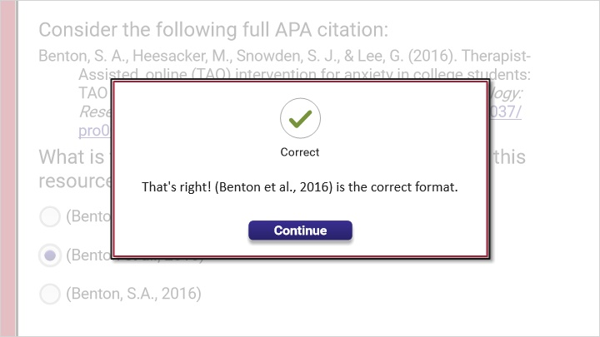

Incorrect (Slide Layer)
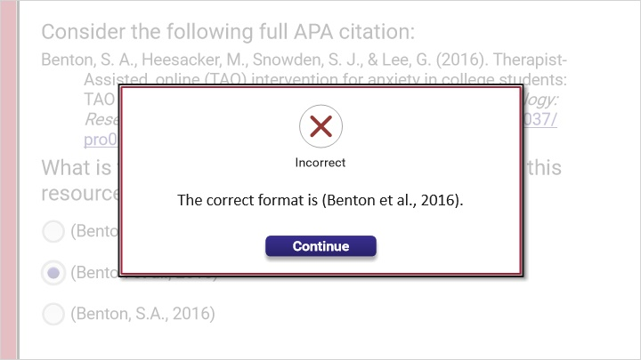

1.12 Try it Yourself!
(Fill-in-the-Blank, 10 points, 2 attempts permitted)
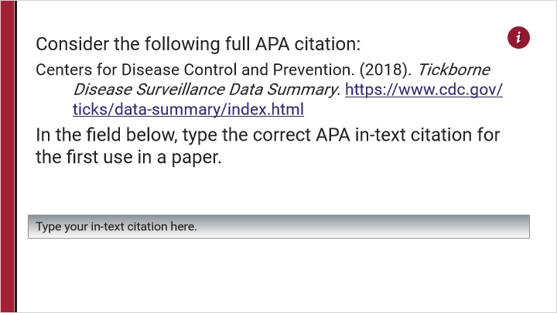
Choice
(Centers for Disease Control and Prevention [CDC], 2018)

Feedback when correct:
That's right! The first citation should spell out the full name of the organization with the abbreviation in square brackets. Subsequent citations will use the abbreviation only (CDC, 2018).
Feedback when incorrect:
Not quite! The first citation should spell out the full name of the organization with the abbreviation in square brackets: (Centers for Disease Control and Prevention [CDC], 2018). Subsequent citations will use the abbreviation only (CDC, 2018).

Notes:

Correct (Slide Layer)
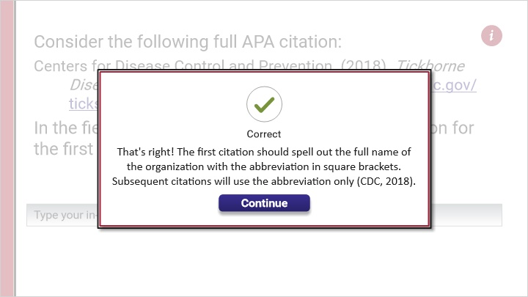

Incorrect (Slide Layer)
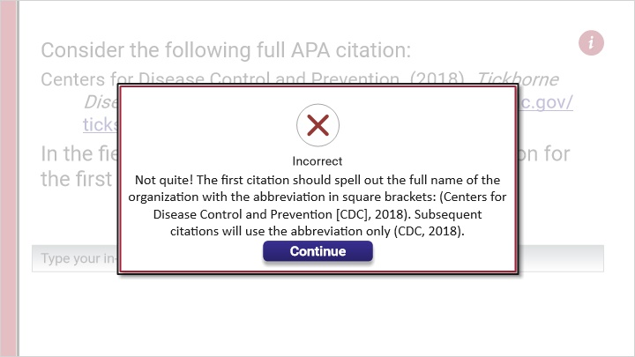

Try Again (Slide Layer)
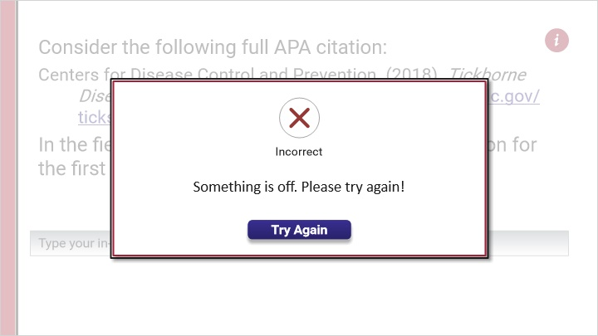

1.13 APA Reference Quick Review
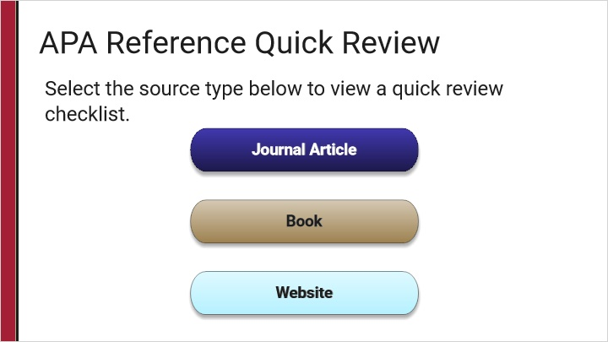
Notes:

Journal Article (Slide Layer)
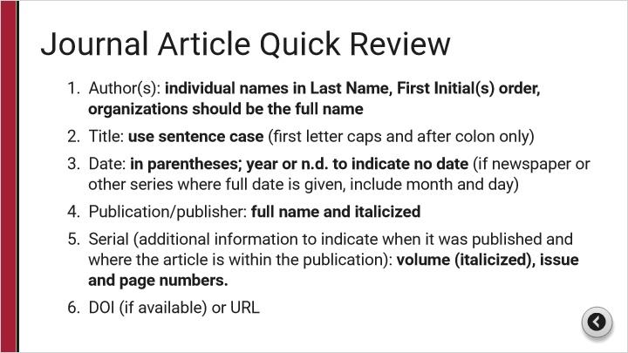

Book (Slide Layer)
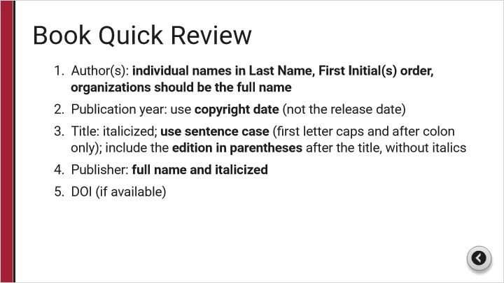

Website (Slide Layer)
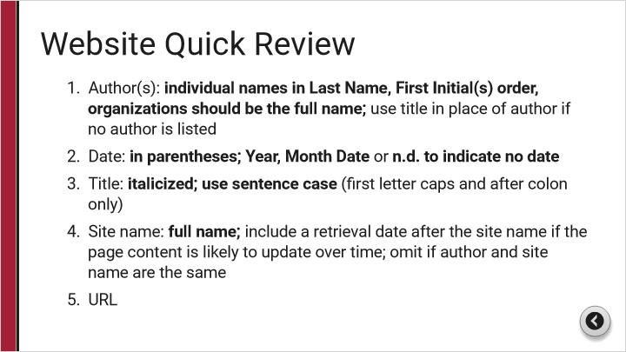

1.14 Contact Us

Notes:
Contact a librarian for additional help!

1.15 Additional Resources and Help

Notes:

1.16 Thank you!

Notes:
Thank you!

1.17 Try it Yourself!
(Hotspot, 10 points, 2 attempts permitted)
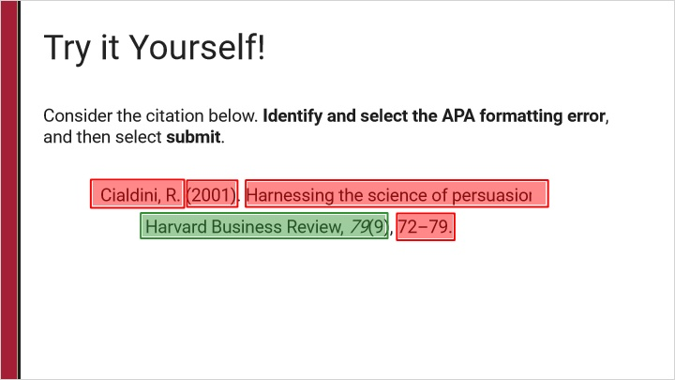
Feedback when correct:
That's right! APA format requires the journal name to be in italics.
Feedback when incorrect:
Not quite! The journal name should be written in italics for APA style.

Correct (Slide Layer)
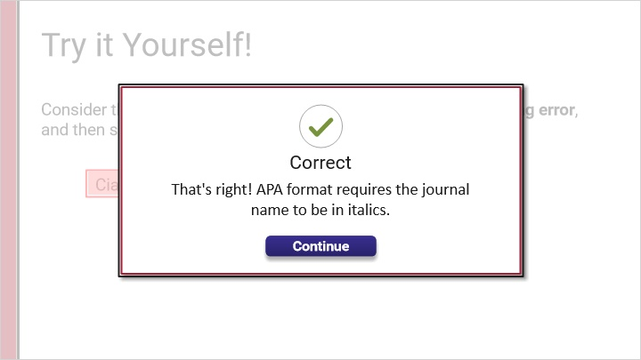

Incorrect (Slide Layer)
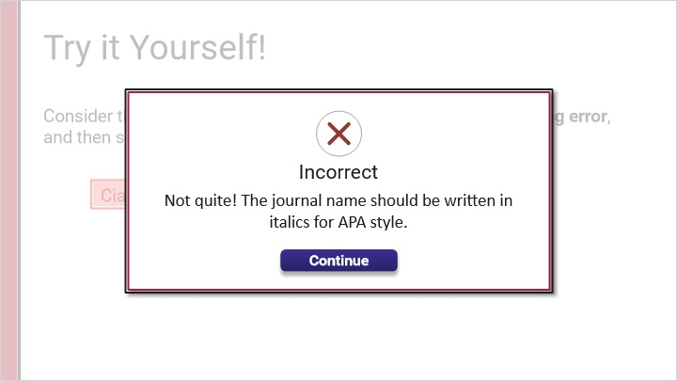

Try Again (Slide Layer)
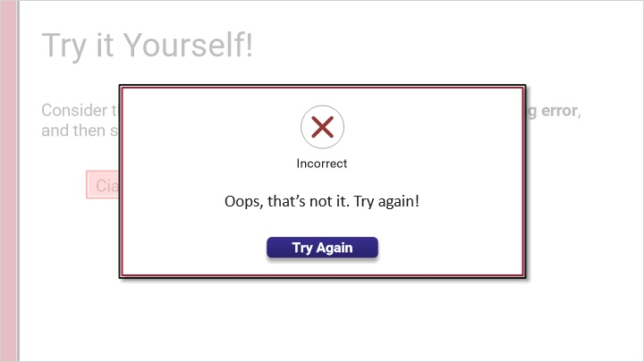

1.18 Try it Yourself!
(Hotspot, 10 points, 2 attempts permitted)
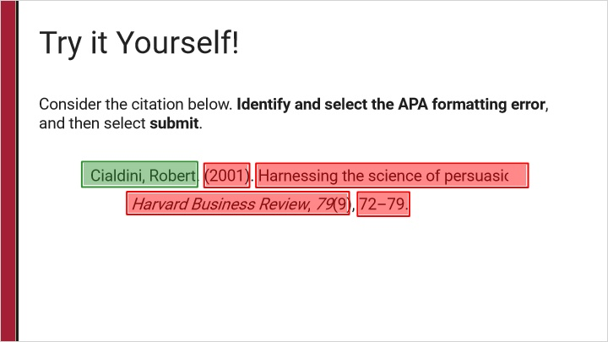
Feedback when correct:
That's right! APA format requires only the first initial of the author’s first name.
Feedback when incorrect:
Not quite! This citation lists the author’s full first name, while APA only requires the first initial of the first name.

Correct (Slide Layer)
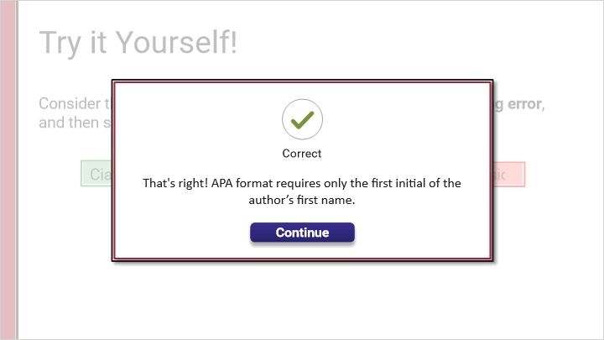

Incorrect (Slide Layer)
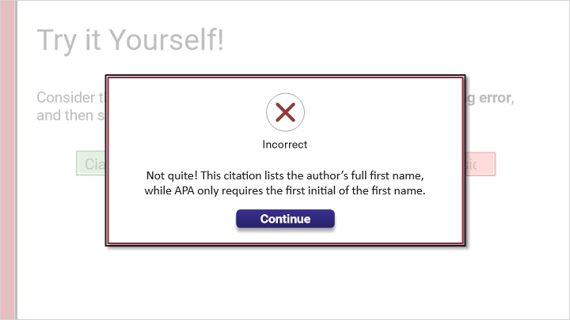

Try Again (Slide Layer)
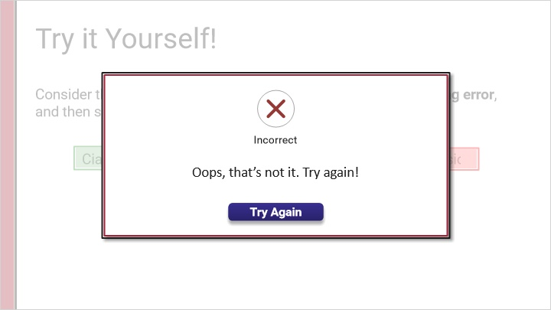

1.19 Try it Yourself!
(Hotspot, 10 points, 2 attempts permitted)
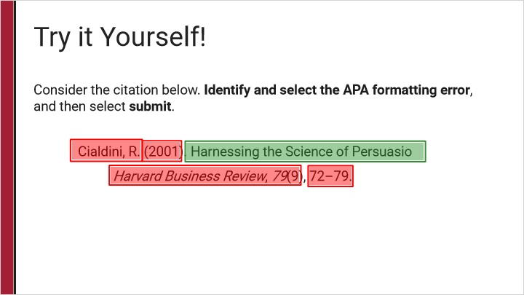
Feedback when correct:
That's right! APA format requires the article title be written in sentence case.
Feedback when incorrect:
Not quite! APA format requires the article title be written in sentence case.

Correct (Slide Layer)
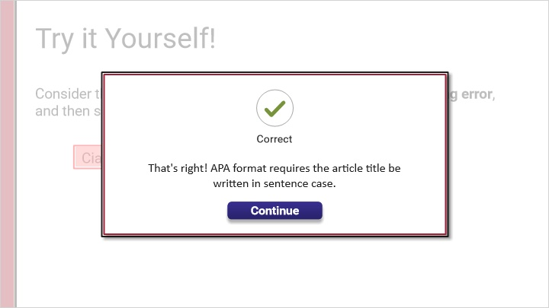

Incorrect (Slide Layer)
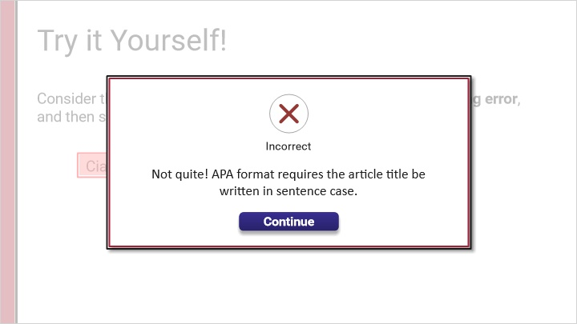

Try Again (Slide Layer)

2. Click the citation part

Q2.1 Try it Yourself!
(Hotspot, 10 points, 2 attempts permitted)
Feedback when correct:
That's right! APA format requires the journal name to be in italics.
Feedback when incorrect:
Not quite! The journal name should be written in italics for APA style.

Correct (Slide Layer)

Incorrect (Slide Layer)

Try Again (Slide Layer)

Q2.2 Try it Yourself!
(Hotspot, 10 points, 2 attempts permitted)
Feedback when correct:
That's right! APA format requires only the first initial of the author’s first name.
Feedback when incorrect:
Not quite! This citation lists the author’s full first name, while APA only requires the first initial of the first name.

Correct (Slide Layer)
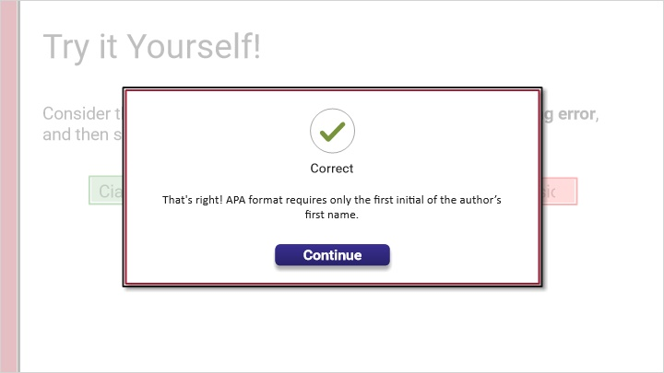

Incorrect (Slide Layer)
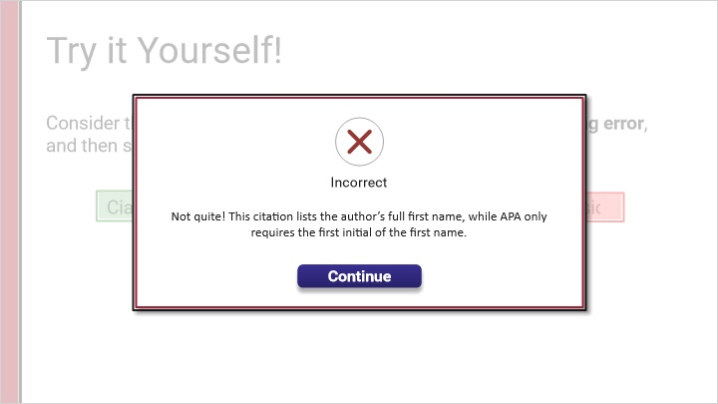

Try Again (Slide Layer)

Q2.3 Try it Yourself!
(Hotspot, 10 points, 2 attempts permitted)
Feedback when correct:
That's right! APA format requires the article title be written in sentence case.
Feedback when incorrect:
Not quite! APA format requires the article title be written in sentence case.

Correct (Slide Layer)
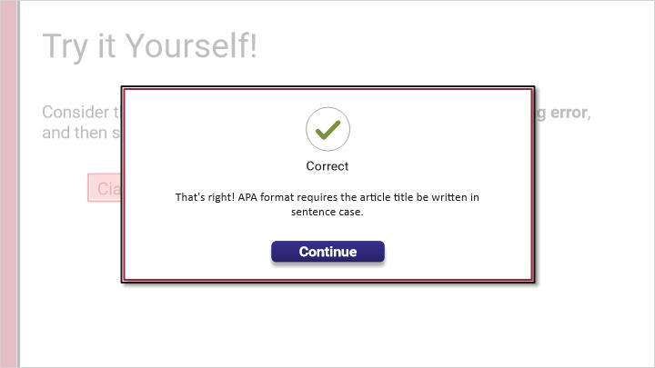

Incorrect (Slide Layer)
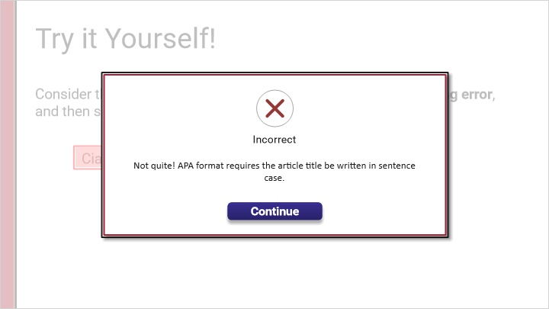

Try Again (Slide Layer)

